Conductors and insulators: Teacher background information
What is a conductor?
Conductors are materials that allow electricity and energy to flow easily. All metals conduct electricity and electrical energy although some conduct better than others, e.g. copper is a much better conductor than stainless steel. This is why copper is commonly used in electrical wire.
A non-metal material that also conducts electricity and electrical energy is graphite (as found in pencils).
Some liquids like salty water can also conduct electricity and electrical energy. This is why it is not safe to have electrical appliances near water, e.g. a hairdryer near bathwater.
What is an insulator?
Insulators are materials that greatly slow down the flow of electricity and energy. Under particular circumstances, some insulators may become conductive if enough electricity or electrical energy is transferred to them. At Year 6 level, it is sufficient for students to consider insulators as materials that prevent electrical and energy flow.
Some examples of materials that can act as insulators are:
- glass
- paper
- teflon
- rubber
- most plastics
- ceramic.
All electrical circuits are made up of a combination of materials that conduct and insulate. The use of insulated materials to cover conductors is essential for electrical safety and prevents electrical shocks.
Sheet Investigating electrical conductors and insulators
In this investigation, students will create a circuit with a gap in it to place different materials to see if they conduct or insulate. An example of the kind of circuit they could make is below:
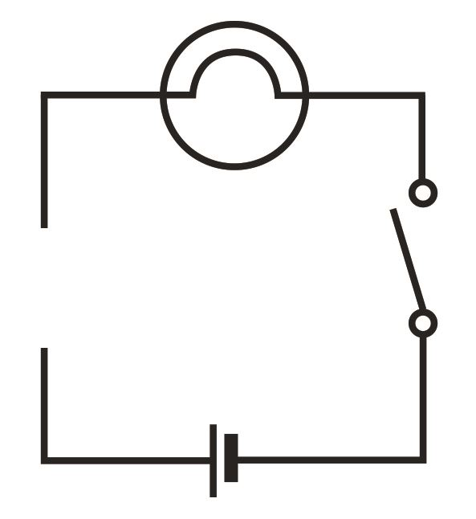
light bulb
space to place materials in the circuit to test
cell
switch

